Photo Flash Slave Trigger
This is a project to make a Slave Trigger for an electronic strobe unit. The Slave Trigger is plugged into the sync cord (PC Type) from a strobe unit and will flash the strobe when it "sees" another flash go off. An older 1970's Epoxy cased slave trigger (AC Plug Style) was used as a guide in developing this new version. Thanks to input from some of my web friends we now use a photocell from a $1 solar powered calculator as the photo diode.
This Project uses a SCR, Capacitor, Resistor, Photo Cell, an Radio Shack Adaptor Plug, and a small plastic box. The parts were found at a local electronic surplus store and the Dollar Store.
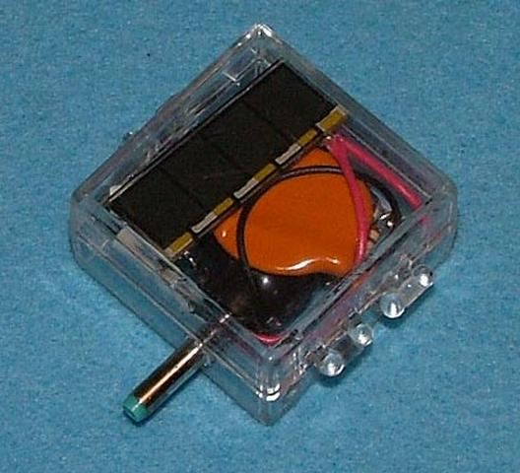 | 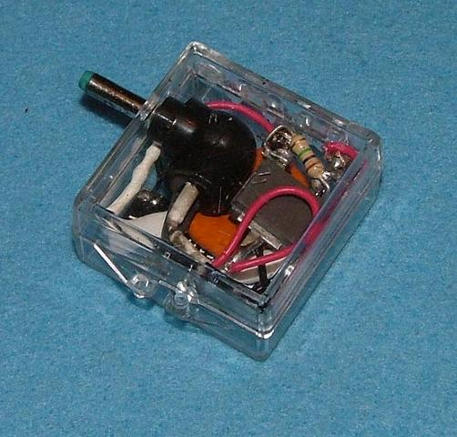
Figure 1 | Figure 2
Completed Unit Top View | Completed Unit Bottom View

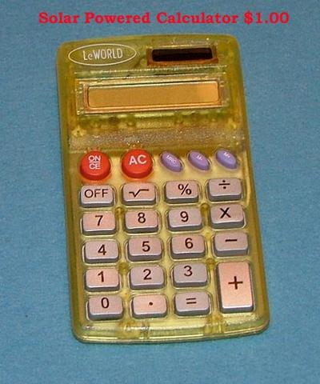 | 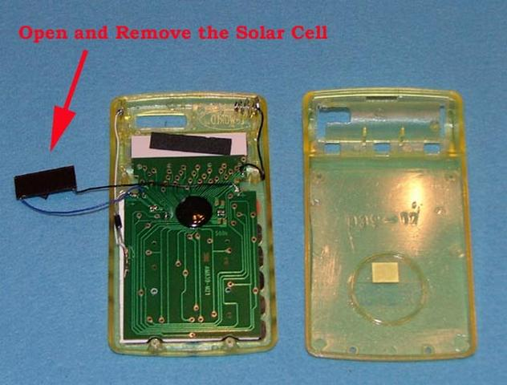
Figure 3 | Figure 4
Solar Powered Calculator from Dollar Tree | Dissassembled Calculator

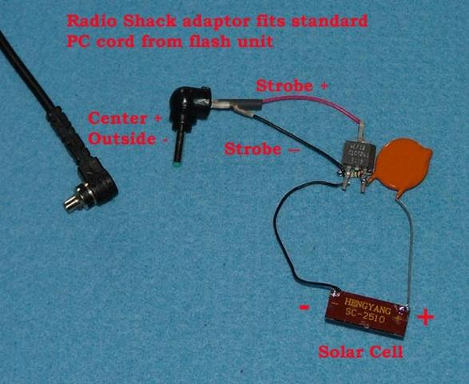 | 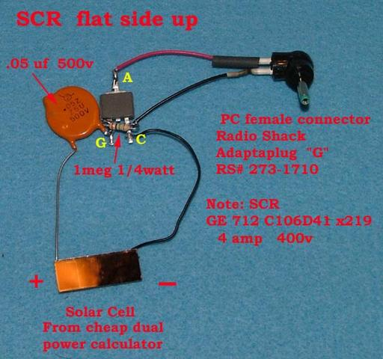
Figure 5 | Figure 6
Circuit Detail Top View (writing on SCR) | Circuit Detail Bottom View ( plain flat side SCR)

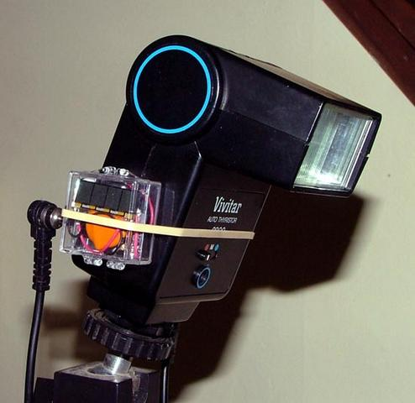 | 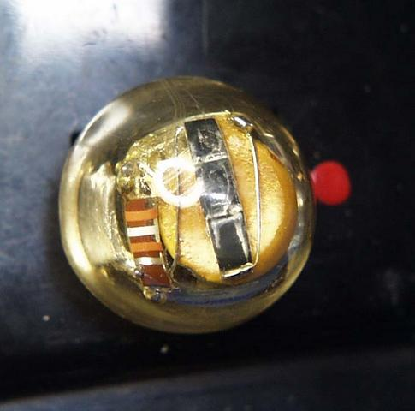
Figure 7 | Figure 8
Strobe Slave mounted on Vivitar flash unit | Original Unit used as a guide

Parts List
SCR | GE 712 C106D41 x219 ( for replacement C106D )  Mouser replacement 526-NTE5457 http://www.mouser.com Digi-Key replacement C106DOS-ND http://www.digikey.com/
Resistor | 1 meg Ohm 1/4 watt
Capacitor | .05uf 500V
Photodiodes | Solar Cell from a $1 solar powered calculator
PC female plug (as on a camera) | Radio Shack "G" plug adaptor RS#273-1710
Small plastic jewlery box

The Slave Trigger will only function if the Positive side of the strobe trigger circuit is connected to the Anode of the SCR and the Negative side is connected to the Cathode. Some Strobes indicate the positive side with a red dot (Graflex), otherwise, if it does not fire the strobe turn it around to reverse the polarity.
I make no claims, warrantees, guarantees that this strobe trigger will work, or for the quality of the information contained here in , experiment at your own RISK!!!!!!
